**MID TERM ONE ASSESSMENTS 2024**

**LEARNING AREA: LITERACY TWO**

**CLASS : PRIMARY TWO**

**PUPIL’S NAME :**

Each correct answer carries two marks.

**SECTION A**

**1.** Write one word for each given sound.

ir: ____________ ght: ______________ bl: ____________

st: ____________ oa: _____________

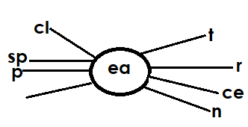**2.** Form words.

_______________________

_______________________

_______________________

_______________________

**3.** Fill in the missing letters.

dr ___ m k ___ te fo ___ d

fa ___ er su ___ t ____ eth

**4.** Read and draw

|  |  |  |  |  |
| --- | --- | --- | --- | --- |
|  |  |  |  |  |
| kettle | bottle | table | pineapple | pot |

**5.** Write the first sounds for these pictures.

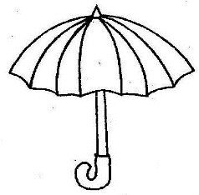

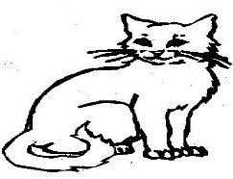



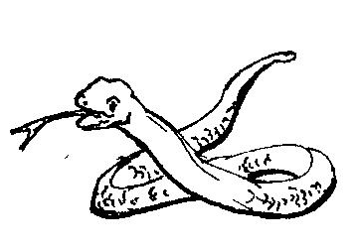

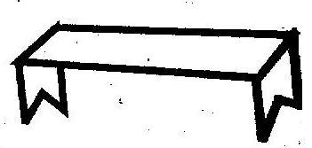



**6.** Circle the word for the given sound.

oi: pail pool soil

ee: dream seed snail

or: snow drum doctor

ea: teacher judge policeman

**7.** Match and write correct words.

uni go ____________________

class plane ____________________

man form ___________________

aero fly ___________________

house room ___________________

**8.** Write your school motto.

_____________________________________________________________________________________

**b)** Write these sentences in their correct order.

1. I go to the classroom.

2. I greet my teachers.

3. I sit down and learn.

4. Mummy drops me at the school gate.

1. ______________________________________________________

2. ______________________________________________________

3. ______________________________________________________

4. ______________________________________________________

**SECTION B**

**9.** Name these pictures

|  |  |
| --- | --- |
|  |  |
|  |  |

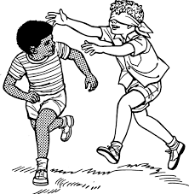**10.** Colour this picture.

**11**. Copy correctly.



________________________________________________________________________________________________________________________________________________________________________________________________________________________________________________________________________



________________________________________________________________________________________________________________________________________________________________________________________________________________________________________________________________________



________________________________________________________________________________________________________________________________________________________________________________________________________________________________________________________________________



________________________________________________________________________________________________________________________________________________________________________________________________________________________________________________________________________